Project Design Phase-II
Data Flow Diagram & User Stories
Date | 12-10-2026
Team ID
Project Name | HotelPro – Hotel Room Booking and Management System – Online Movie, Event & Entertainment Ticket Booking System
Maximum Marks | 4 Marks
Data Flow Diagrams:
A Data Flow Diagram (DFD) illustrates how data moves within the HotelPro hotel room booking and management platform. It shows how users (customers/guests, hotel staff/receptionists and administrators) and external systems (payment gateway and SMTP email service) interact with the system, how information flows between processes, and where the data is stored in MongoDB collections. The diagrams below follow the SRS and are drawn at two levels: Level 0 (context) and Level 1 (major processes).
Legend:
Symbol | Meaning
Rectangle | External entity (user or external system)
Circle | Process that transforms data
Open-ended bar (D1–D5) | Data store (MongoDB collection)
Arrow | Data flow, labelled with the data moved

DFD Level 0 – Context Diagram:
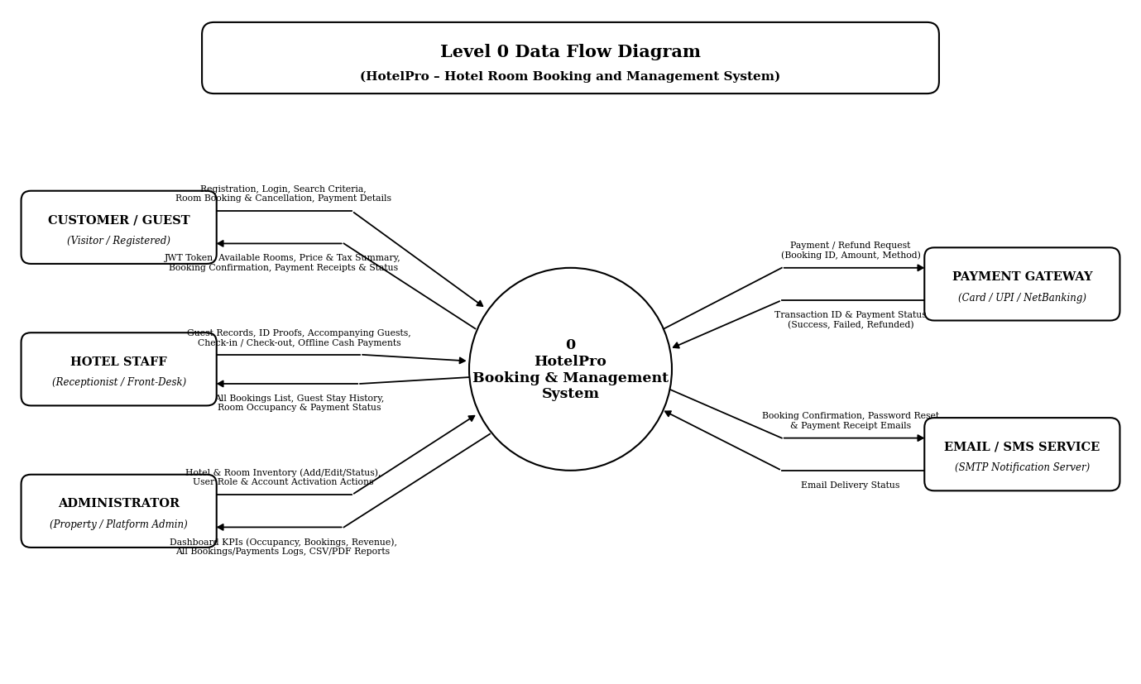

Figure 1: DFD Level 0 – HotelPro

DFD Level 1 – Major Processes:
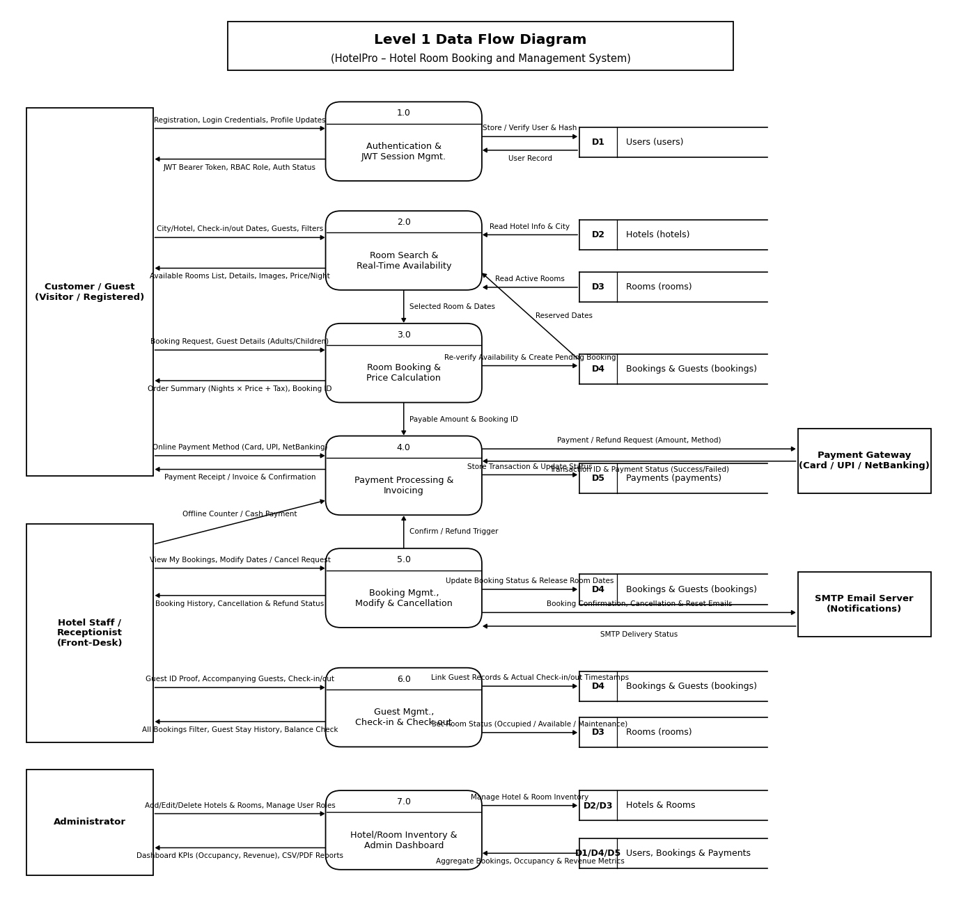
Figure 2: DFD Level 1 – HotelPro (processes 1.0 to 7.0, data stores D1 to D5)

Level 1 Process Description:
No. | Process | Description | Data Stores
1.0 | Authentication & JWT Session Mgmt. | Visitor registration, email/password validation, bcrypt password hashing, login/logout, JWT issue, profile update and RBAC middleware | D1 (users)
2.0 | Room Search & Real-Time Availability | Search by city/hotel, check-in/check-out dates and guest count; filter/sort by price, room type, amenities and rating; date validation and sub-2s availability check | D2 (hotels), D3 (rooms), D4 (bookings)
3.0 | Room Booking & Price Calculation | Total amount calculation (pricePerNight × nights + taxes), confirmation-time availability re-verification, guest details capture, unique booking ID generation (Pending) | D3 (rooms), D4 (bookings)
4.0 | Payment Processing & Invoicing | Online payment via gateway (card, UPI, net banking) without storing raw card data; offline cash/counter payment recording; status update to Confirmed and receipt generation | D4 (bookings), D5 (payments)
5.0 | Booking Mgmt., Modify & Cancellation | Customer My Bookings history; date modification and pre-check-in policy-based cancellation; automatic room release for freed dates; staff/admin search and filter | D3 (rooms), D4 (bookings), D5 (payments)
6.0 | Guest Mgmt., Check-in & Check-out | Guest record CRUD (contact, address, ID proof type/number, accompanying guests); front-desk check-in/check-out with actual timestamps, balance check and room status update (Occupied/Available/Maintenance) | D3 (rooms), D4 (bookings)
7.0 | Hotel/Room Inventory & Admin Dashboard | Admin hotel and room CRUD, room status control, active-booking deletion guard, user role/status management, KPI analytics (occupancy, bookings, revenue) and CSV/PDF report export | D1 (users), D2 (hotels), D3 (rooms), D4 (bookings), D5 (payments)
User Stories
User Story Table – HotelPro
User Type | Functional Requirement (Epic) | User Story / Task | Acceptance Criteria | Priority | Release
Customer | User Registration & Auth (FR-REG, FR-JWT) | As a visitor, I can register with my name, email, phone and password and log in with JWT authentication so that I can book rooms. | Email uniqueness and 8+ char password validated; password hashed with bcrypt; signed JWT returned on login. | High | Sprint-1
Customer | Room Search & Availability (FR-SRC) | As a customer, I can search rooms by city/hotel, check-in/check-out dates and guest count, and filter by price, room type, amenities and rating. | Past dates or invalid ranges rejected; only unbooked rooms for selected dates returned in under 2 seconds. | High | Sprint-3
Customer | Hotel Room Booking (FR-BKG) | As a logged-in customer, I can reserve an available room for selected dates and enter primary and accompanying guest details. | Availability re-verified at confirmation to prevent double booking; total (nights × price + taxes) and unique Pending booking ID generated. | High | Sprint-3
Customer | Payment Processing (FR-PAY) | As a customer, I can pay online using credit/debit card, UPI or net banking through the integrated payment gateway and receive an invoice. | No raw card/CVV data stored; transaction ID recorded; booking becomes Confirmed only after successful payment. | High | Sprint-4
Customer | Booking Management & Cancellation (FR-BMG) | As a customer, I can view my current, upcoming and past bookings, modify dates or cancel a booking before check-in. | Cancelled booking updates status, triggers eligible full/partial refund and releases the room for the freed dates. | High | Sprint-4
Customer | Profile & Password Reset (FR-REG) | As a registered user, I can view and update my profile details and reset my password via my registered email. | Updated profile details persist in MongoDB; unauthorized requests without valid Bearer JWT return HTTP 401. | Medium | Sprint-1
Hotel Staff | Guest Management (FR-GST) | As hotel staff, I can add, view, edit and search guest records (contact, address, ID proof type/number and accompanying guests) linked to bookings. | Guest records linked to one or more bookings; personal data restricted to authorized staff and admins (HTTP 403 otherwise). | High | Sprint-5
Hotel Staff | Front-Desk Check-in (FR-CIO) | As a receptionist, I can check in an arriving guest against a confirmed booking at the front desk. | Booking status updates to Checked-in, room status updates to Occupied and actual check-in date/time is recorded. | High | Sprint-5
Hotel Staff | Front-Desk Check-out & Billing (FR-CIO, FR-PAY) | As a receptionist, I can record offline counter payments, verify balance completion and check out a departing guest. | Outstanding balance verified; booking updates to Checked-out, actual check-out timestamp logged and room set to Available/Maintenance. | High | Sprint-5
Hotel Staff | Staff Booking Console (FR-BMG) | As hotel staff, I can view, search and filter all reservations across the hotel by booking status, date range or guest name. | Console accurately filters Pending, Confirmed, Checked-in, Checked-out and Cancelled bookings in real time. | High | Sprint-4
Administrator | Hotel & Room Inventory (FR-HRM) | As an administrator, I can add, edit or delete hotels and rooms (Single, Double, Deluxe, Suite) and manage room operational statuses. | Only Admin role allowed; rooms with active or upcoming bookings are blocked from deletion. | High | Sprint-2
Administrator | Admin Dashboard & Reports (FR-ADM) | As an administrator, I can manage user roles/accounts, monitor dashboard KPIs (bookings, occupancy rate, revenue) and export reports. | Dashboard displays daily/weekly/monthly charts, booking/payment logs and exports reports in CSV or PDF format. | High | Sprint-6

